
CS 120 Web Programming
Assignment 10: Deliverables

Web App 1:

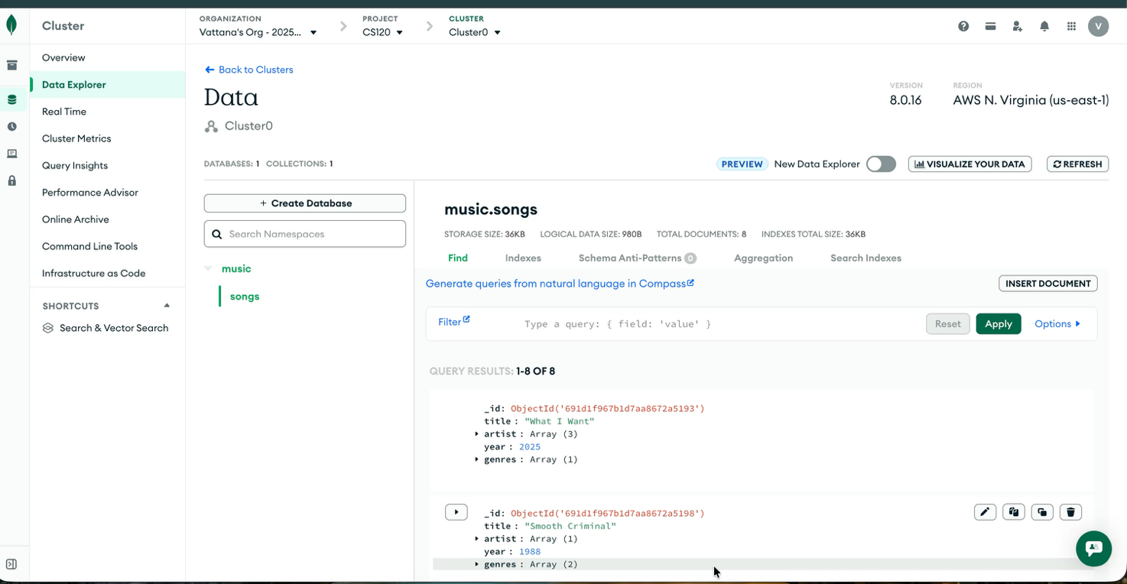
- Link to demo video online
app 1 video_______________________
- All .js files zipped as app1.zip
- Screen shot of populated database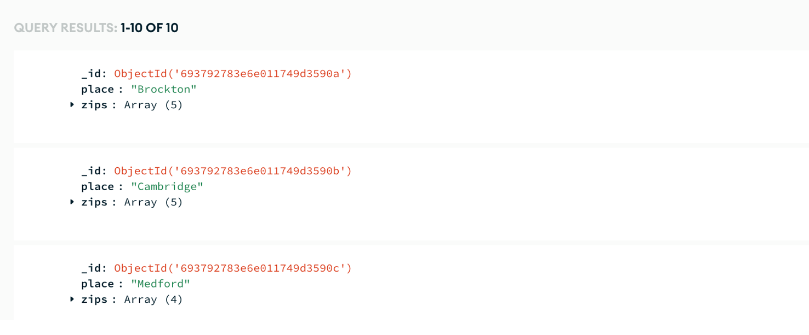
- Copy/paste below results from the console
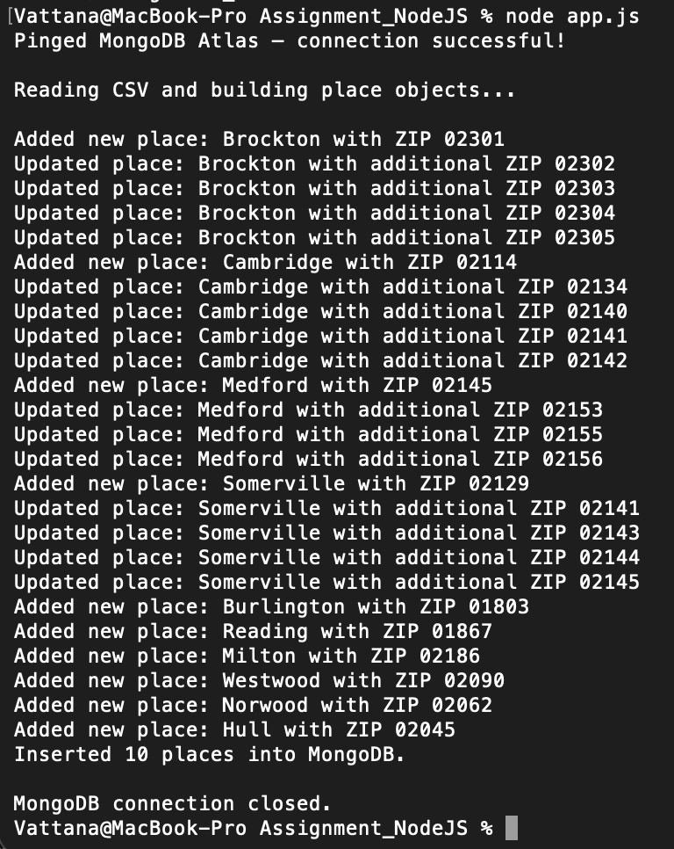
Web App 2:
- URL of app working online ________________________
- Check if the app writes to the console plus the server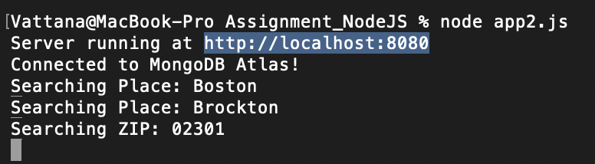
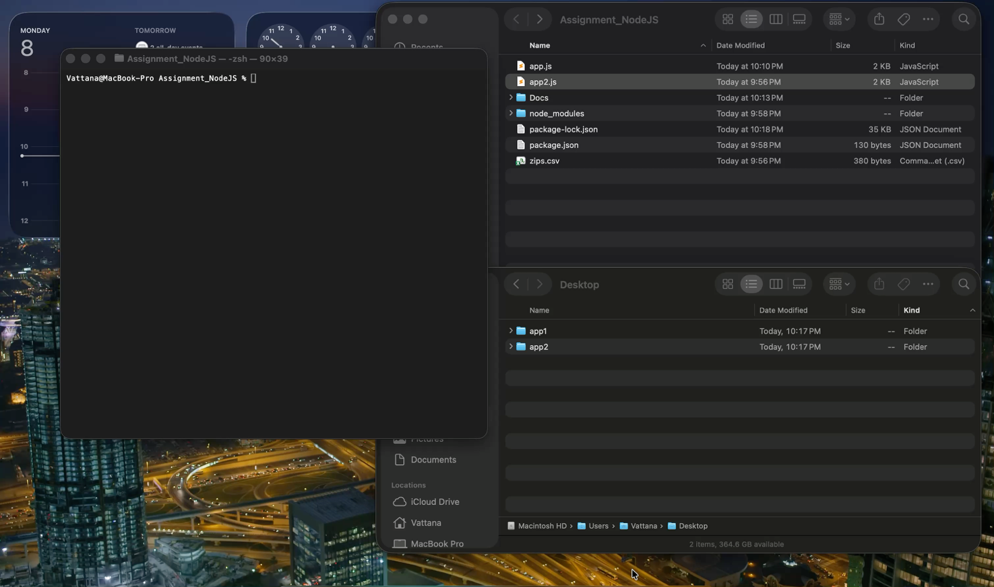
- Link to demo video online
app2 video
- All .js files zipped as app2.zip

Answer question:
Which do you prefer: node.js or php? Node.js
Explain your preference: I prefer node.js because I can use javascript for both frontend and backend. I also feel like it responds faster than php.

